BIOLOGY (CELL DIVISION AND REPLICATION)
Student Name
Course

Lab Module 6 and 7: Mitosis, Cell Cycle, and DNA Processing (Chapters 6 and 9)
Name: Adriana Ramos
Introduction
One main tenet of the cell theory is that “All cells arise from preexisting cells.” This happens through the process of cell division in which new cells are formed when a “parent cell” divides itself into two new “daughter cells.” In prokaryotes and single-celled eukaryotes, cell division is essential for reproduction and continued existence of a species (although the specifics of the process differ somewhat between these two groups of organisms). In multicellular, eukaryotic organisms, cell division is necessary for the growth of the organism and for the replacement of damaged or worn-out cells.
In most Eukaryotic organisms, reproduction is “sexual,” meaning that offspring are produced by the union of two sex cells (gametes), specifically an egg cell and a sperm cell. When these two cells unite (fertilization), the resulting cell is called a zygote. This zygote then undergoes many cell divisions (growth) to eventually produce the multicellular offspring.
The “life cycle” of a cell may be thought of as being from the time a cell is produced by the division of a parent cell until the time it undergoes cell division to produce two new daughter cells. This cycle is called the “cell cycle” and is shown in a diagram in your textbook. The cell cycle is a continuous process but has been divided into different phases by scientists for a better understanding of the various events that take place. These phases consist of interphase (including G1, S, and G2), mitosis (a division of the nucleus including prophase, metaphase, anaphase, and telophase), and cytokinesis (a division of the cytoplasm).

Learning Outcomes
Upon successful completion of this lab, you should be able to:
1. Define/explain each of the following terms: cell cycle, mitosis, cytokinesis, chromosome, DNA, sister chromatid, chromatin, centromere, nuclear membrane, spindle (microtubules), and centrosomes.
2. Demonstrate and explain mitosis using chromosome models.
3. Identify the stages of the cell cycle, including all stages of interphase and the mitotic phase.
4. Distinguish between mitosis and cytokinesis.
5. Identify the processes involved in nuclear and cell division.
6. Understand the regulatory roles of the cell cycle checkpoints. Understand the consequences of a failed checkpoint.
7. Understand the roles and consequences of failures of oncogenes and tumor-suppressor genes.

PART A: Observation of the phases of mitosis in Onion Root Cells

Materials:
Prepared slide of an onion root tip
Microscope

- Go to the virtual microscope lab:
http://www.ncbionetwork.org/iet/microscope/
- Click on Explore
- Go to “plant cells.”
- Choose onion root tip
- Find cells in each phase of the cell cycle and mitosis
Example Images:
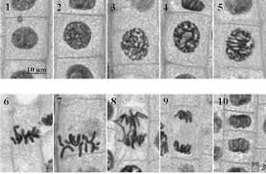
1,2 Interphase
3,4,5 Prophase/Prometaphase
6,7 Metaphase
8 Anaphase
9 Telophase
10 End of Telophase (cytokinesis) formation of daughter cells.

In your drawings Label, the pertinent parts present on each drawing, including the:
Cell wall, cytoplasm, nucleus, chromatin, nuclear membrane (note if it is dissolving or forming), spindle fibers, poles (these are regions, not structures), metaphase plate, sister chromatids (also note when they are pulled apart), chromosomes.
Drawings of six phases of the cell cycle:
Interphase  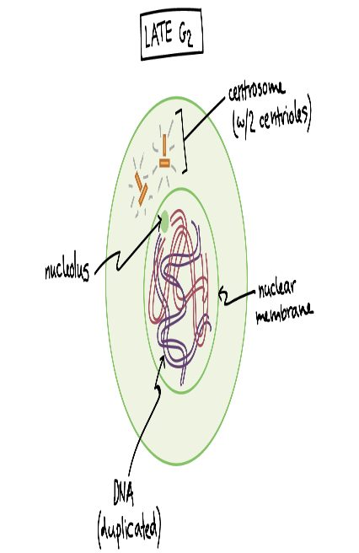 | Prophase  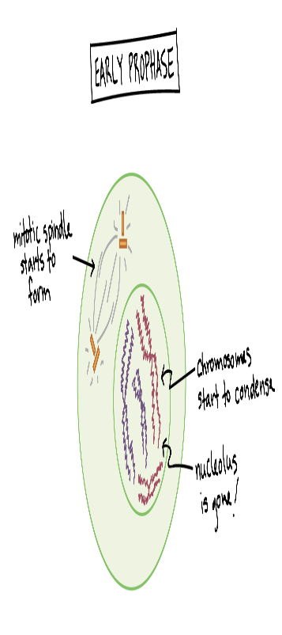 | Metaphase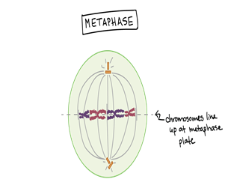

Anaphase  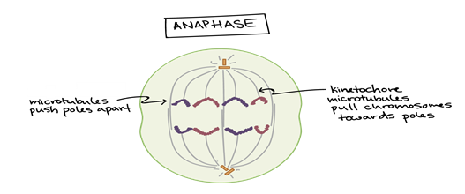 | Telophase  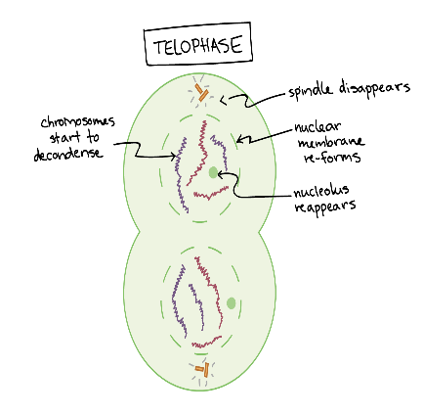 | Daughter Cells  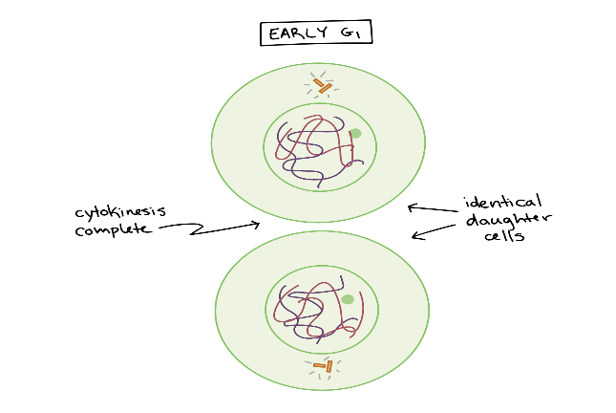

PART B: Regulation of the Cell Cycle
Access the following URL: http://www.hhmi.org/biointeractive/eukaryotic-cell-cycle-and-cancer read the summary, download, and print the Overview Worksheet, (right side of the screen) and then click on “Start Click and Learn” link to access the interactive lesson on the Eukaryotic Cell Cycle and Cancer.
Complete the Overview Worksheet and answer the questions below:
Name three specific actions that occur in prophase.
- There is the formation of spindle fibers
- Formation pf cell structure reading to chromosomes division
- Part of the nucleus starts to disappear
What is the cell doing during G1? S? G2?
At G1 and G2, the cells are developing, showing growth. They are also producing proteins, thus preparing the cell for growth.
What do different cell cycle checkpoints look for?
They look for the implication of the DNA or the replication of the chromosomes during the mitosis division. They ensure that there is no unpredictable DNA replication as well as the activation of the MFP
What is apoptosis? What purpose does it serve?
It is a term used by the biologist to describe what they call the orchestrated collapsing old cells behaviors through the membrane blebbing, cell shrinkage, chromatins condensation as well as the fragmentation of the DNA following the massive engulfment of corpses of the neighboring cells.
Purpose
Its main purpose involves the embryogenesis processes, aging, and the study of many diseases.
What is the difference between an oncogene, proto-oncogene, and a tumor suppressor gene?
Proto-oncogenes are the gene that enhances the growth of the cell, while oncogenes are those genes that result or cause the cell to divide abnormally or out of control.
Tumor suppressor is the kind of genes which function to slow down the division of
Cells, repair of DNA mistakes, or even predict the time of cell death.
Can you draw a cell undergoing mitosis?
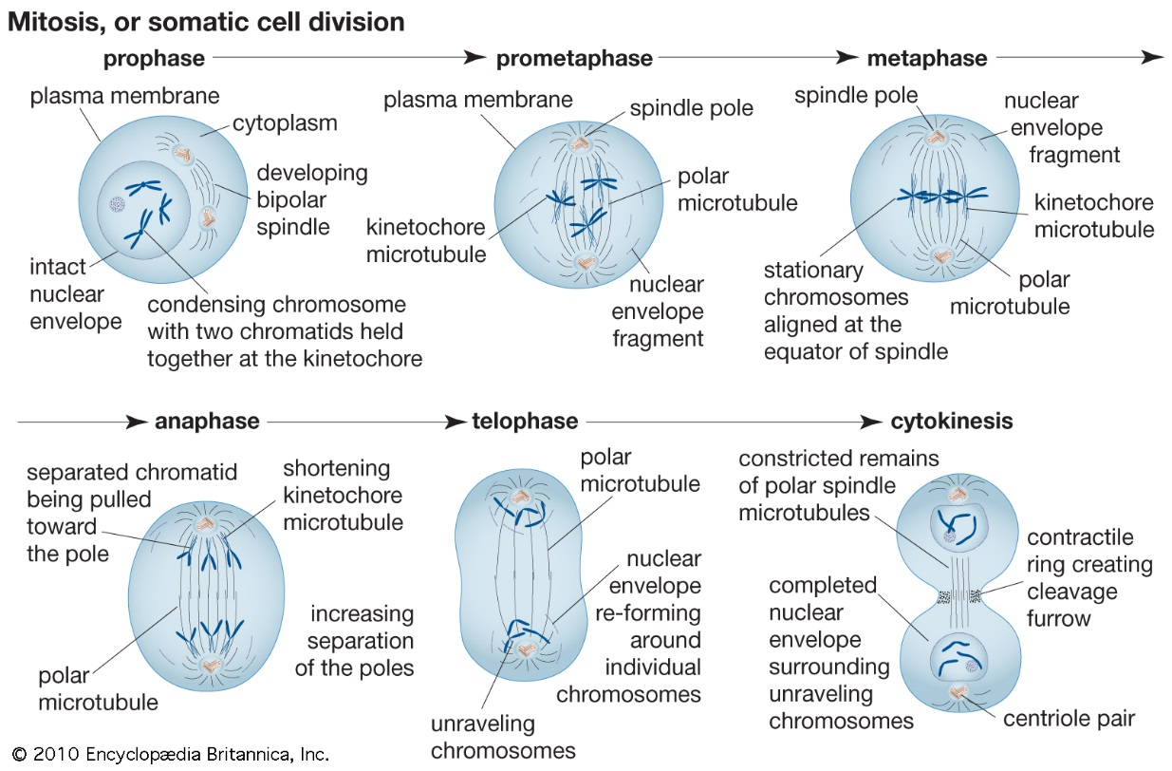
a cell undergoing mitosis division
Part C: DNA Processing
Learning Outcomes
Upon successful completion of this lab, you should be able to demonstrate:
1. An understanding of the complementary and antiparallel structure of the double-stranded DNA molecule.
- The process of DNA replication, including the names of all enzymes, structures, and the overall procedure. Be able to distinguish between processes of the leading vs. lagging strands, and understand how these processes relate to the antiparallel structure of DNA.
3. An understanding of the process and products of transcription.
4. An understanding of the process and products of translation, including the ability to translate a messenger RNA to produce a polypeptide (protein).

Part 1: DNA Structure and Replication
A DNA molecule is made of two strands that “complement” each other in the sense that the molecules that compose the strands fit together and bind to each other, creating a double-stranded molecule that looks much like a long, twisted ladder. Each side rail of the DNA ladder is composed of alternating sugar and phosphate groups. The two sides of the ladder are not identical but are complementary. These two backbones are bonded to each other across pairs of protruding bases, each bonded pair forming one “rung” or cross member. The four DNA bases are adenine (A), thymine (T), cytosine (C), and guanine (G). Because of their shape and charge, the two bases that compose a pair always bond together: A always binds with T, and C always binds with G.

Your instructor might give you an activity to explore the molecular structure of DNA using puzzles, models, or pen-and-paper exercises. Make sure you use these activities to reinforce your understanding of the complementary and antiparallel structure of DNA.

The particular sequence of bases along the DNA molecule determines the genetic code. Therefore, if the two complementary strands of DNA were pulled apart, you could infer the order of the bases in one strand from the bases in the other, complementary strand. For Example, if one strand has a region with the sequence AGTGCCT, then the sequence of the complementary strand would be TCACGGA.
Question 1: fill in the blanks below to create a complementary and antiparallel sequence of DNA: 3’- G A_ T G A _A T _C G A C _T A _A T -5’ Coding
DNA... _C G A _T _C G _T A _T _C G T _G C _ ... Template
In order for an organism to grow, develop, and maintain its health, cells must reproduce themselves by dividing to produce two new daughter cells, each with the full complement of DNA as found in the original cell. DNA replication is the copying of DNA that occurs before cell division can take place (see ‘DNA replication’ Figure 1 below).
Figure 1. DNA Replication. The copying of DNA.
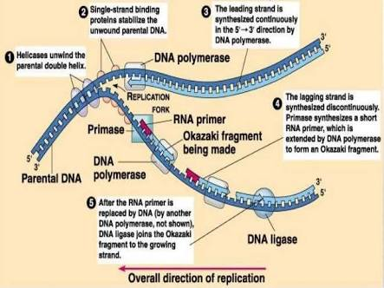
- To learn more about this process of DNA replication, watch the following video.
https://www.youtube.com/watch?v=TNKWgcFPHqw
- After you have gained an understanding of DNA replication, complete the following diagram using the following terminology list
Helicase
RNA primase
DNA polymerase (3 times)
DNA ligase
Okazaki Fragment (3 times)
Leading Strand
Lagging Strand
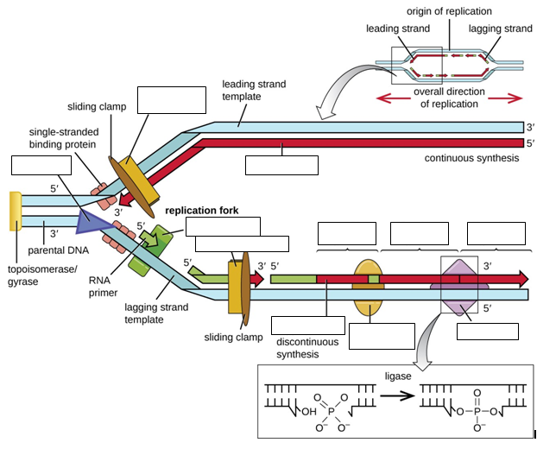
Check, your understanding:
- In what direction does DNA polymerase read the template DNA strands?
It leads the template DNA strands into the 3’ to 5’ direction, and from this, this nit creates a new strand from the nucleotide following the 5’ to 3’ direction.
- In what direction are the new DNA strands built?
The DNA strands are built.t into two directions, which are the 5’ to 3’ and direction 3’ to 5.’
5’ to 3’ lagging strand
3’ to 5’leading strand
- What enzyme forms Okazaki fragments?
The DNA polymerase enzymes
- What enzyme joins Okazaki fragments?
DNA ligase
- Explain the relationship between the replication fork(s) and the replication bubble?
The relation between the replication forks and the replication is that the replication forks are formed when the DNA opens up, forming two of Y- structure, which results in the formation of replication bubbles.
- Why does DNA have to be replicated?
The purpose of DNA replication is for the formation of new cells to form. It also needs to replicates before any new is formed so that the upcoming new cell may receive information and instruction from the parent cell through the DNA replication.

Part 2: Protein Synthesis

Review the process of protein synthesis (transcription and translation) from your classroom notes, textbook sections, or your instructor may play a video for you. Your instructor might also have you model the process using puzzles, models, or paperwork exercises. Use these activities to reinforce your understanding of the two steps (transcription/translation), as well as how they are affected by the Complimentary and antiparallel nature of DNA and the rules of DNA – RNA base pairing.

SUMMARY Figure 2 (below). The making of a protein following the instructions encoded in DNA, via the processes of Transcription and Translation. DNA holds all of the genetic information necessary to build a cell’s proteins. The nucleotide sequence of a gene is ultimately translated into an amino acid sequence of the gene’s corresponding protein.
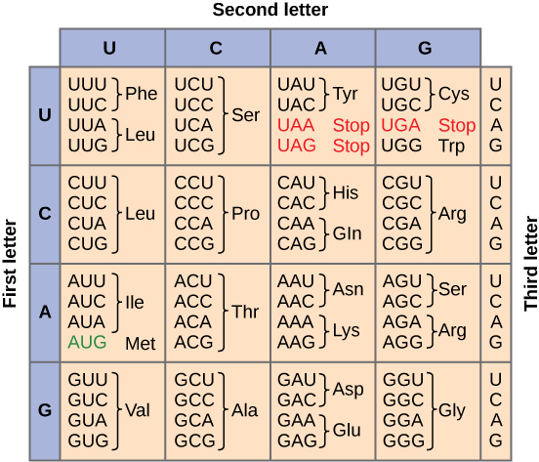
Figure 3 (at right). The Genetic Code for translating each nucleotide triplet, or codon, in mRNA into an amino acid or a termination signal in a nascent protein.
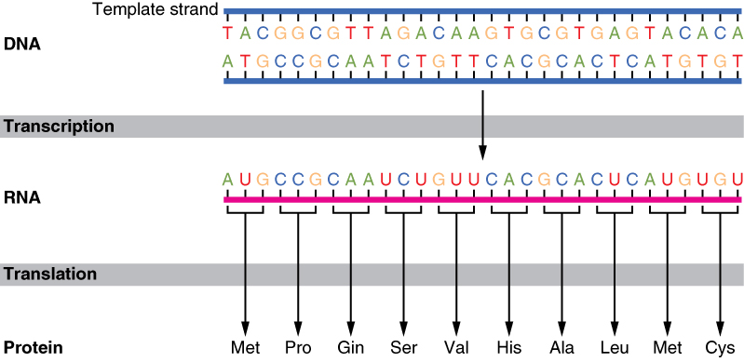
Use the following worksheet and figure 3 (preview page) to explore the processes of protein synthesis:

Transcription
DNA non-template strand sequence: ___G ___C ___ A ___C ___T __A __G __A __T ___A ___G
DNA template strand sequence: 3’ T A C C C A C G T C C A 5’
5
3
mRNA strand sequence: _C _G _U _ G _A _U _C __U _ A _ U _C __G

DNA non-template strand sequence: ___G ___C ___ A ___C _ U _ C __U _ A _ U
Separate the DNA template and the mRNA strands. In a cell, the mRNA strand would undergo some “editing,” including the addition of the 5’ CAP, the 3’ poly-A tail, and removal of the introns. Then it would leave the nucleus, and the DNA strand would rejoin with its complementary half by reforming the hydrogen bonds between complementary base pairs.
Translation
` In the cell, the mRNA leaves the nucleus through a pore in the nuclear membrane. Once in the cytoplasm, it attaches to a ribosome and is “read” three base pairs at a time to determine the appropriate amino acid that should be inserted in the growing protein. A block of three consecutive nucleotides in the mRNA is called a codon. The ribosome (which is made of ribosomal RNA or rRNA) is comprised of two subunits named the 40S subunit and the 60S subunit (You can think of the “S” as a unit of weight measurement). The transfer RNA (tRNA) function to bring specific amino acids to the ribosome to be used in building the specific protein. Each tRNA has a three-base sequence on one end called the anticodon and a sequence CCA on the other, which serves as an attachment site for the tRNA’s specific activating enzyme.
The activating enzyme is responsible for catalyzing the chemical reaction of joining the amino acid to the tRNA.
The anticodon on the tRNA is complementary to the codon on the mRNA, which explains how the correct amino acid is brought to the site of translation.
Template DNA base sequence: 3’ T A C C C A C G T C C A 5’

mRNA codons: (5’ to 3’) ___U __C __A _G

tRNA anticodons: __G___ ___C___ _A__ ___U___

Amino acid sequence aa1_____ aa2____ aa3____ aa4___
Template DNA base sequence: 3’ T A C C C A C G T C C A 5’
mRNA codons: (5’ to 3’) ___U __C __A _G
tRNA anticodons: __G___ ___C___ _A__ ___U__
Amino acid sequence aa1_____ aa2____ aa3____ aa4___
6. In the previous lab on DNA replication, we discussed that errors could occur during the replication process.
Typically, these errors are corrected by proofreading enzymes, but sometimes mistakes persist. A mistake that results in a single base change is called a point mutation and may affect the amino acid composition of the resulting protein.

- How would the protein have been different if the DNA template sequence was T-A-C-C-G-A-C-C-T-C-C-G? Note: Use the table of the genetic code included earlier in this lab:

This is a termination of the gene from a DNA structure, which causes the protein to change into amino acid
Template DNA base sequence: 3’ T A C C G A C C T C C G 5.’
mRNA codons: (5’ to 3’) __A__ __U__ __C__ ___G___
tRNA anticodons: __A____ __C____ ___T___ __G____
Amino acid sequence: ___U___ ___C___ __A____ ___G___
- Do all point mutations cause a different amino acid to be inserted?
Not all point mutation that leads to the assertion of different amino acid. For Example, the silent mutation does not have any effects on the amino acid.
c) Notice from the table of the genetic code (included at the end of this lab) that 61 codons represent the 20 different amino acids. Why do you think it is advantageous, from a genetic perspective, to have this redundancy (i.e., the same amino acid is represented by more than one codon)?
7. Once the translation is complete, the protein, the mRNA, and the two subunits of the ribosome separate. In a cell, the resulting protein would be passed into the endoplasmic reticulum, where it would undergo further modifications before being used within the cell or exported to other locations within an organism.
8. If the base sequence on a template strand of DNA was TACTATGCCATT, what would be the sequence of the codons on the mRNA transcribed from this DNA?
5’ __U___ __A___ __G___ __U___ _A____ __U___ __G___ ___C__ __C___ ___A__ __U___ ___U__ 3’
9. What would the sequence of bases of the anticodons on the tRNA be?
3’___U__ __U___ __C___ __U___ ___U__ ___U__ _C____ __G___ __G___ ___U__ __U___
__U___ 5’
10. What would be the sequence of amino acids that would be translated from this DNA?
_____U____ ____C_____ __G_______ _____U____
11. If a mistake (point mutation) was made during the replication of this strand so that the new DNA strand had the base sequence TACACAGCCATT, what would be the resulting change in the protein built from this strand?
______T___ ____G_____ _____C____ ___T______
12. Complete the following table using the information provided:
Non-Template DNA Strand | TAC | TGC | Ser | TTC | TCC
Template  DNA Strand | GUG | GCG | Ala | GGG | GAG
mRNA (5’ to 3’) | CUU | CGU | ala | CUU | CCU
tRNA anti-codon | UUG | UCG | Ser | UAG | UUG
Amino Acid | UUC | UGC | Leucine | UUC | UUC

13. What is the difference, with respect to transcription, between the template and non-template DNA strands?
With respect to transcription, template strand is a DNA strand which causes the polymerization of RNA, thus making a new complimentary of specific RNA molecules while none—template strand the duplicate of the original DNS strand after transcription.
14. What are the DNA-DNA rules of complementary base pairing?
The rule of DNA-DNA complimentary is the one that tells us that if only we understand and read the nucleotide of a given one strand, then it possible to immediately analyze or deduce the complimentary.
15. What are the DNA-RNA rules of complementary base pairing?
The rule of DNA-DNA complimentary is the one that tells us that if only we and read and understand the one DNA strand, then it becomes easier to deduce the other strand complementary sequences. Chargaff’s rule.
16. What are the RNA-RNA rules of complementary base pairing?
The RNA-RNA base pairing has a more likely base structure as those of the DNA-DNA base paring. However, the thymine (T) in DNA structure is replaced by Uracil (U)
Here T=U
17. Distinguish between a codon and an anticodon. How are they similar? How are they different?
Differences
A codon is found in the mRNA while the anticodon is basically found in tRNA
Codon mostly determines the amino acid position while the anticodon is known to bring a codon to a specific amino acid.
Similarity
The similarities between codon and anticodon are that they are both involved in the modification of amino acid.
18. What are the functions of the mRNA, tRNA, and rRNA in translation?
The three take an active part in the synthesis of the protein pathway during translation in the cell.
mRNAs, carry out the function of imitating the codon in the methionine of eukaryotic. While the work of the tRNAs in protein synthesis is decoding the mRNAs.
19. In the genetic code table, three codons (UAA, UAG, and UGA) are associated with “STOP.”
What does this mean with regard to translation?
It is mean the triplet nucleotide within the massager mRNAs has carried out a termination codon that signals out of the termination of the translation into given proteins.
More Practice:
Fill in the blanks – either the DNA sequence, the mRNA sequence, or the amino acid sequence.
1) DNA 5’- G C A A T G G G T A C A C A A T G A C G -3’ Coding
3’- C G T T A C C C A T G T G T T A C T G C -5’ Template
mRNA ... C_ G_ U_ U_ U_ C_ C_ C_ U_ U_ G_ U_ G_ U_ U_ U_ C_ U_ G_ C_ -3’
2) DNA
5’- G C A A T G G G T A C A C A A T G A C G -3’ Coding
3’- C G T T A C C C A T G T G T T A C T G C -5’ Template

mRNA ...5’ G_ C_ U_ U_ U_ G_ G_ G_ U_ U_ C_ U_ C_ U_ U_ U_ G_ U_ C_ G_ -3.’
Protein Met __G_ _C__ _G__
3) DNA
5’- G G A _T _U _C _C _C _U _T _G _T _G _T _T _C _T _ G_ C_ -3’ Coding
...5’ G_ C_ U_ U_ U_ G_ G_ G_ U_ U_ C_ U_ C_ U_ U_ U_ G_ U_ C_ G_ -3’
mRNA 5’- G G A T_ T_ C G G G U G C A U U A A C C G ...
Protein Met __G_ __G_ __A_

What are the components of a DNA nucleotide? It has three components which are;
- A nitrogenous base: cytosine (C), guanine (G), adenine (A), thymine (T)
- Five carbon sugar
- Phosphate molecules
What are the four nitrogenous bases in DNA molecules?
Cytosine C, Thymine T, Adenine A, and Guanine G
What are the components of an RNA nucleotide?
The three components are Ribose sugar, a phosphate group, and lastly, the base.
What are the four nitrogenous bases in RNA molecules?
Cytosine C, Uracil U, Adenine A, and Guanine G
What are the percentages of thymine, cytosine, and guanine in a DNA molecule that is 30% adenine?
Guanine and cytosine share 20%, each was making it to 40%, a60% for both adenine and thiamine. They both share 30% each since they are equal.
What is meant by the “central dogma” of biology?
The central dogma in biology means the genetic information which explained within the biological system. It majorly the flow of information.
What are the effects of base substitutions on a protein?
The effects of base substitution are the occurrence of mutations such as nonsense, missense, and silent mutations.
What are the effects of an addition or deletion on a protein?
The deletion of the protein mostly results in the premature STOP codon and also the amino lost.
Where in a eukaryotic cell is DNA found?
It’s found in the cell nuclear
Part D: Putting it all together
- In the diagram below state when each of these events occurs:
DNA Replication, Mitosis, Transcription, Translation, G1 checkpoint, G2 checkpoint, M checkpoint,

- State one major event that happens in each sub-phase and checkpoint.
- G1: at this phase, the cell acquires all the necessary conditions which are beneficial for cell division.
- G1 checkpoint:
At this point, the DNA is normally assessed at this point. Observation of the genomic DNS damage and the restriction of the cell moving to the next stage without having acquired all the necessary conditions.
- S phase: at this phase the point at which the DNA synthesis takes place
- G2: The cell growth occurs at this phase
- G2 checkpoint: at this point, the duplication of the chromosome is mostly assessed. G1 point ensures that all the chromosomes have undergone replication and that the DNA has not yet been damaged.
- M: The formation of the two daughters at this phase
- M checkpoint:
This phase happens towards the end of the metaphase stage. What happens at this stage is the attachment of sister chromatid to the spindle fibers.
- Why does the M checkpoint need to happen before Anaphase?
The M checkpoint needs to occur first before the anaphase because it’s at M checkpoint that the spindle fiber first attach themselves to the centromere to form two pairs of sister chromatids. The two pairs are the core basis for the formation of old daughter cells.

